Mail only: 6, Trem-y-Mynydd Court, Blaenavon NP4 9LX
info@agentlewis.wales 07947 125191
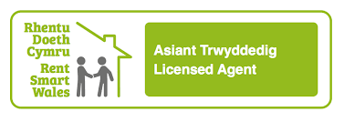
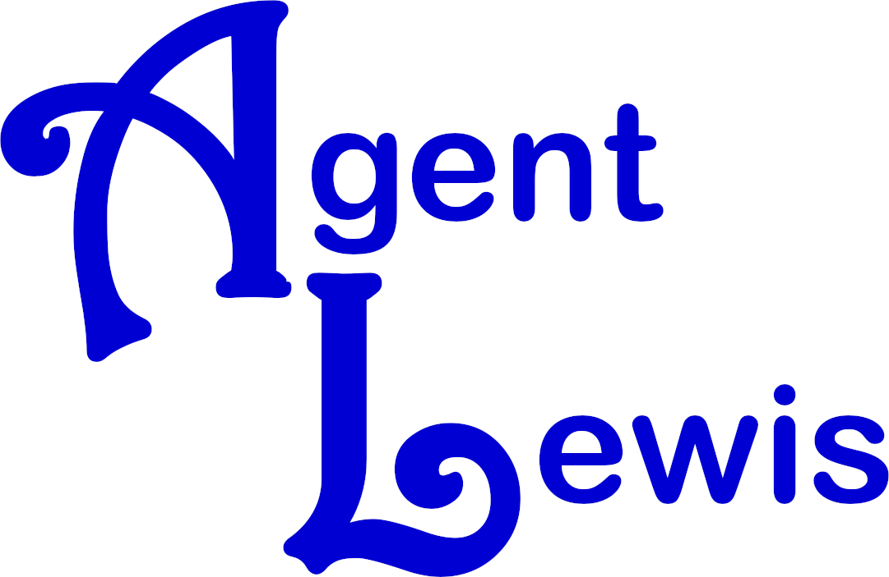

Complaints Procedure

We are committed to providing a professional service to all our clients and customers. If things go wrong we need you to tell us about them. This will help us to improve our service going forward and resolve issues as soon as possible.
If you have a complaint, please put it in writing (letter or email) to us. We will then acknowledge and respond in line with the timescales and stages set out below.

Stage 1- Your complaint
Please put your complaint in writing either by letter or email and address it to ourselves. Please include as much detail as possible, including dates, name of any one you dealt with, enclosing/attaching any supporting evidence.

Stage 2- Our acknowledgement
Your complaint will be acknowledged within three working days and we will start our in house complaints procedure.
Timescale – 3 working days.

Stage 3- Our Investigation
Your complaint will be investigated and we will provide a formal written response addressing your specific complaints and proposing resolution where appropriate.
Timescale – 15 working days of receiving your complaint.

Stage 4- Review of the decision
If you are not happy with our response, you can request a meeting with our principal who would investigate the complaint for you. She will then provide a formal written final viewpoint letter.
Timescale – 7 working days from the date a review is requested.

Stage 5 - Citizen’s Advice, Environmental Health or the Property Redress Scheme
If you remain dissatisfied following the final viewpoint letter, you can then seek advice from Citizen’s Advice or the local Environmental Health Department (depending on the type of problem). It can also be referred to the Property Redress Scheme.
Property Redress Scheme
Premiere House,
1st Floor,
Elstree Way,
Borehamwood,
WD6 1JH.
0333 321 9418
info@theprs.co.uk

